Estimation of Business Expenses
1.Introduction
1.1.Overview:
The primary business requirements for this report are to visualize and analyze business expenses, provide industry-specific insights, identify cost drivers, highlight outliers, and offer interactive functionality. Stakeholders need a visual representation of expenses to compare and analyze spending patterns across different businesses and industries. The report should facilitate the identification of key cost drivers, enabling stakeholders to understand the primary factors contributing to expenses. Additionally, it should flag any outliers or anomalies for further investigation.
1.2.Purpose:
The analysis of business expenses and financial management has a significant social impact. It contributes to economic stability by optimizing costs and fostering long-term sustainability. Effective expense management creates job opportunities and supports the workforce. It allows for better resource allocation, enabling businesses to invest in innovation and community engagement. Responsible expense management aligns with societal expectations and promotes social responsibility. Non-profit organizations benefit from expense analysis, enabling them to maximize their impact. Overall, analysing and managing expenses positively influences economic growth, employment, stakeholder well-being, and social responsibility.
2.Problem Statement & Design thinking
Analysing business expenses has a profound impact on various aspects of business operations. It helps optimize costs, improve profitability, and ensure financial stability. Expense analysis enables businesses to allocate resources effectively, make informed decisions, and create realistic budgets and forecasts. It enhances competitiveness, attracts investors, and mitigates financial risks. By understanding and managing expenses, companies can drive growth, maintain a strong financial position, and make strategic business decisions with confidence.

2.1.Empathy map

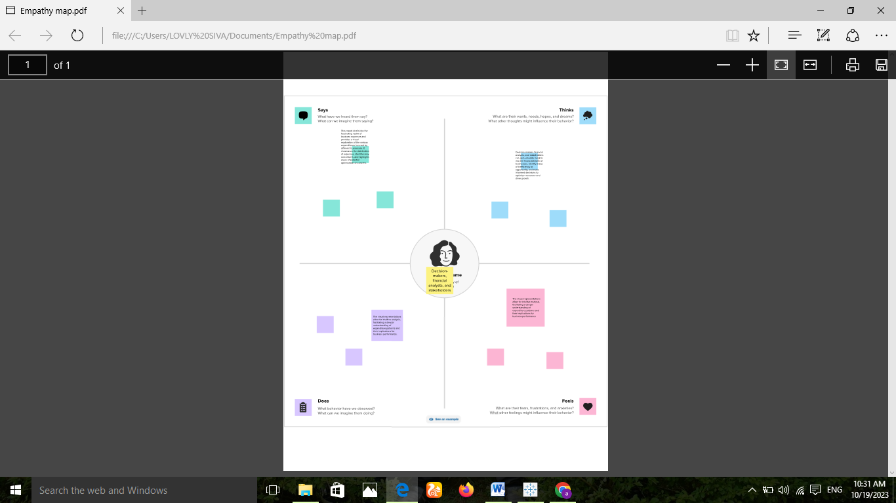

2.2.Ideation and Brainstroming MAP

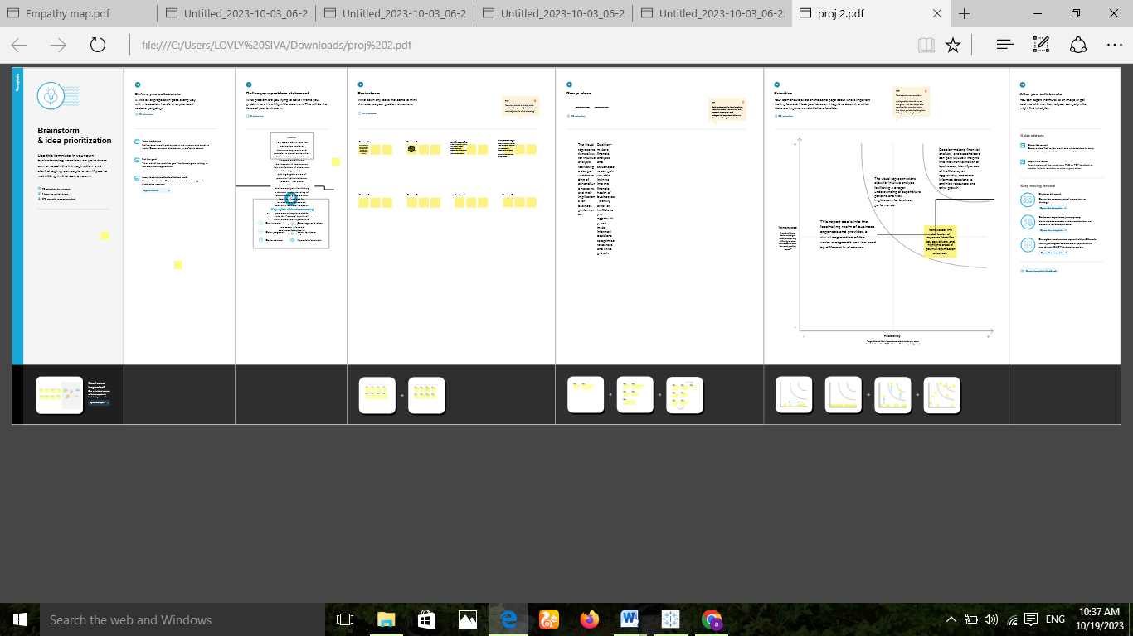

3.Result

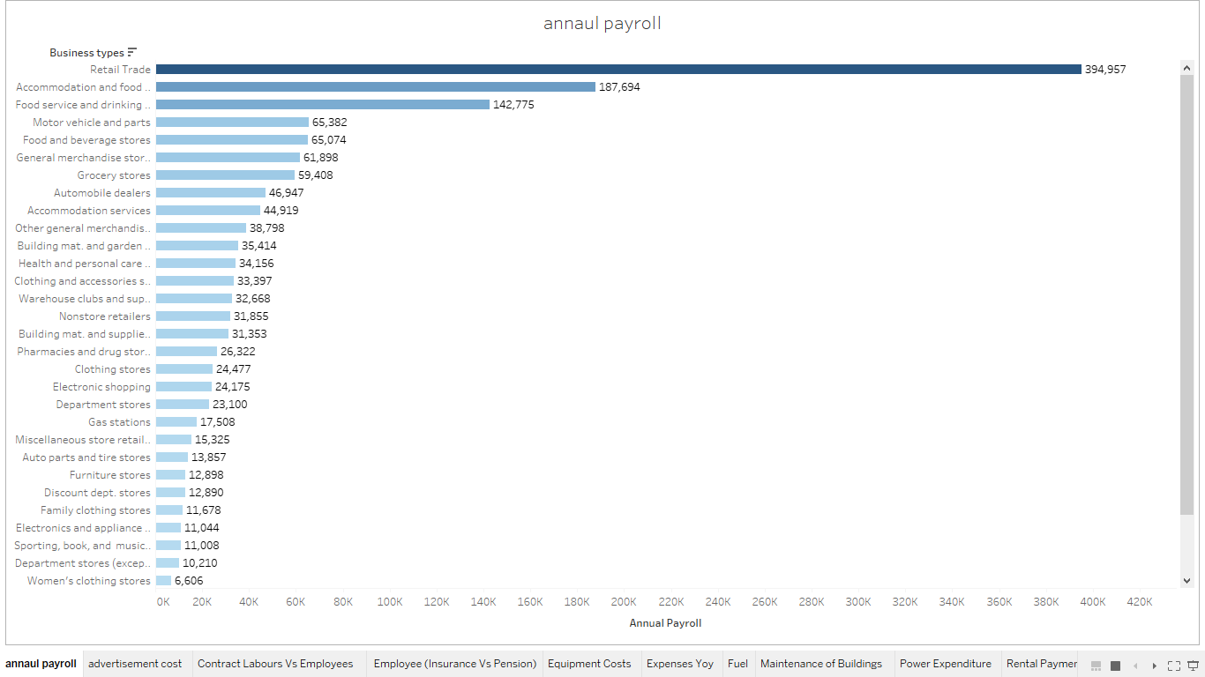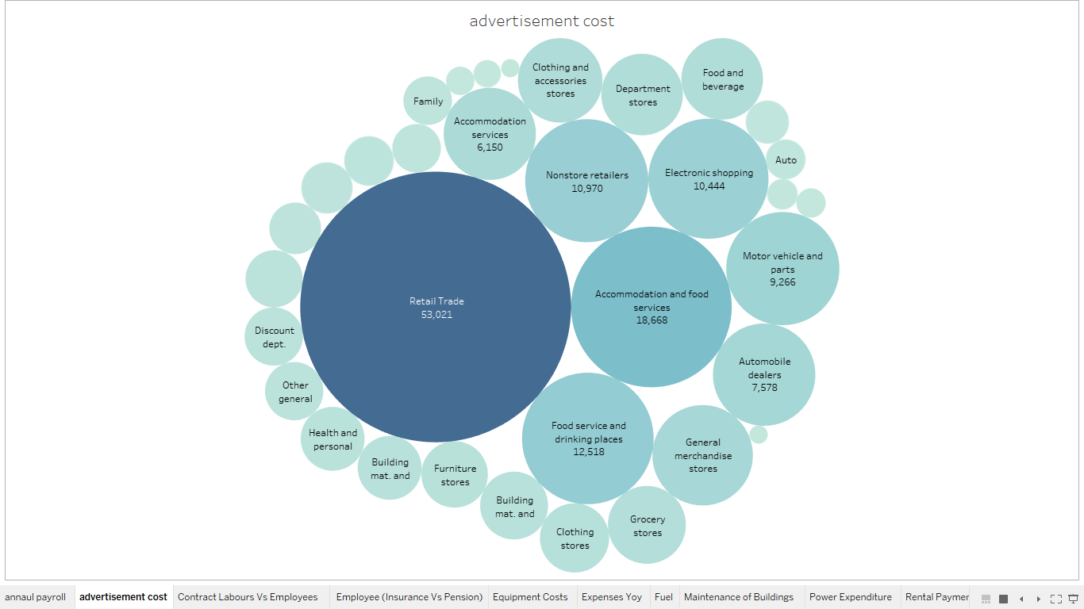

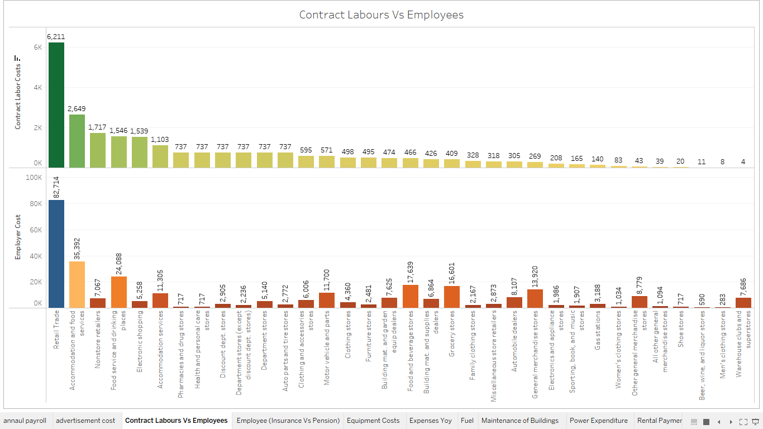

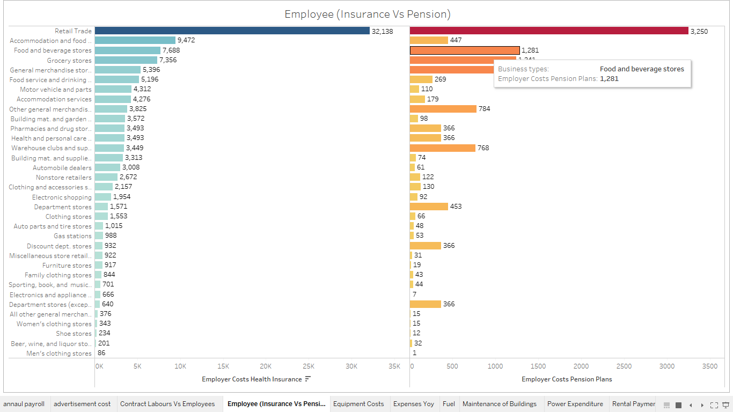

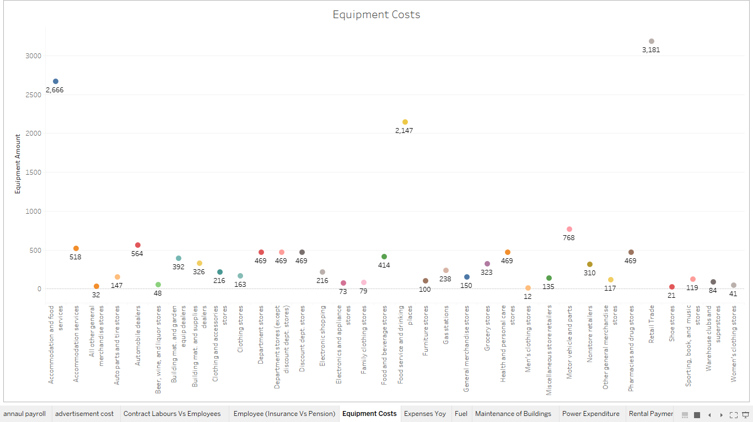

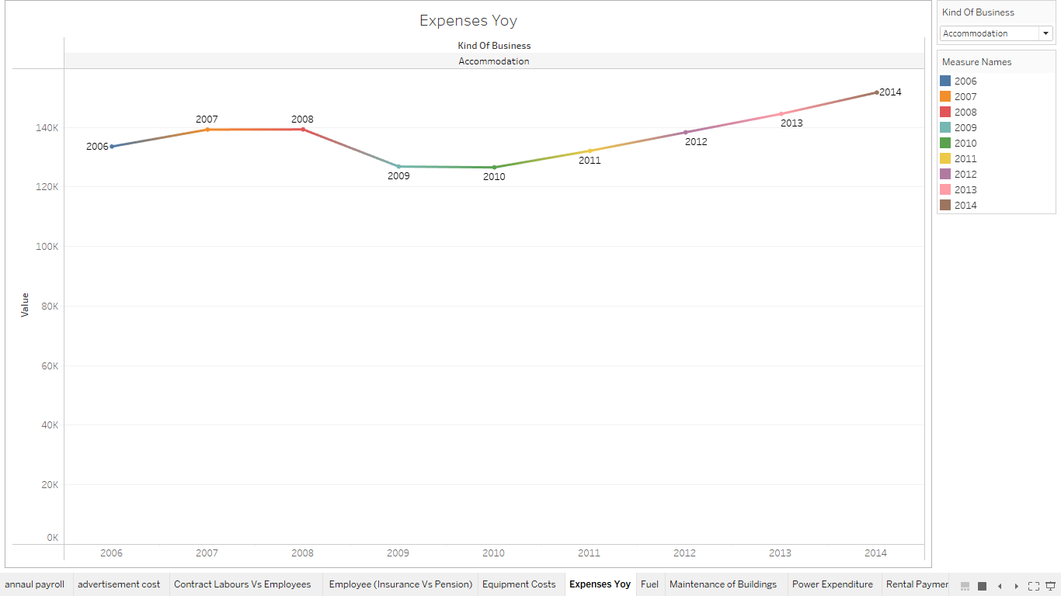

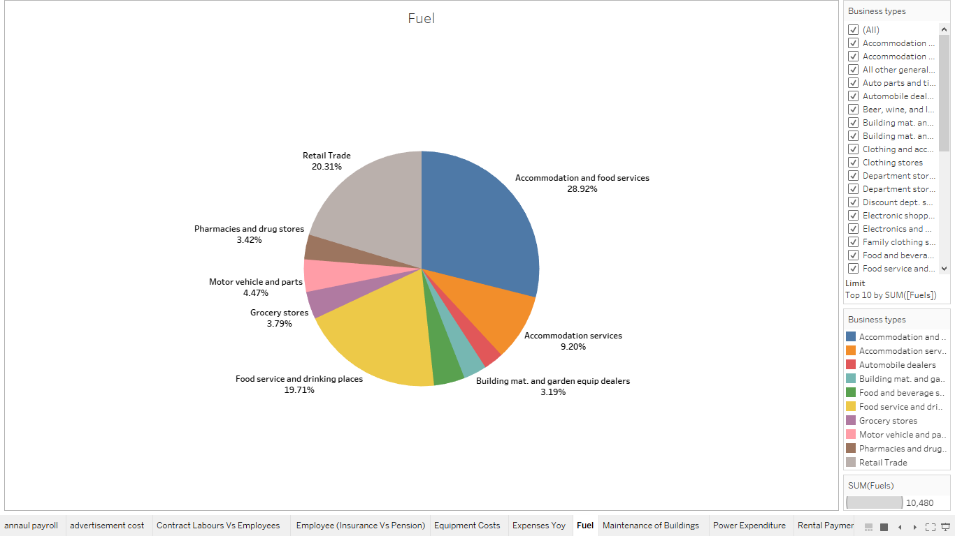
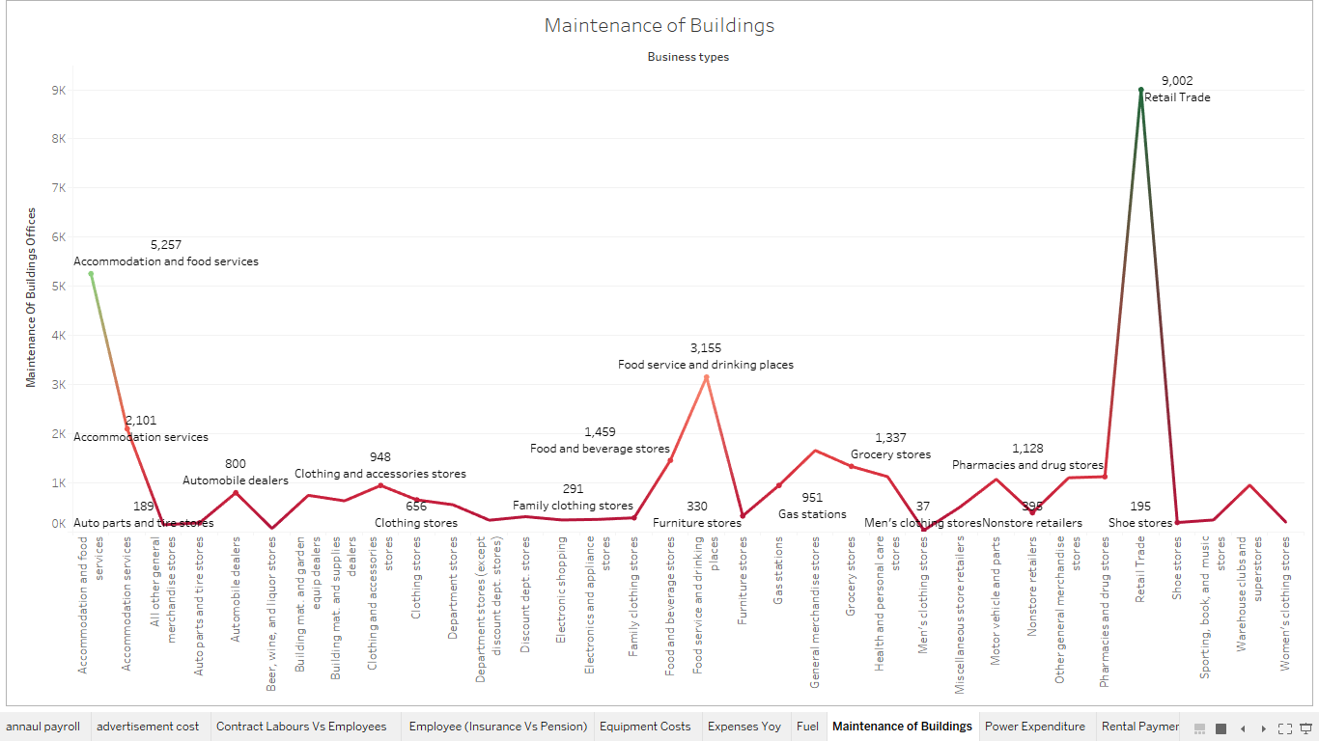

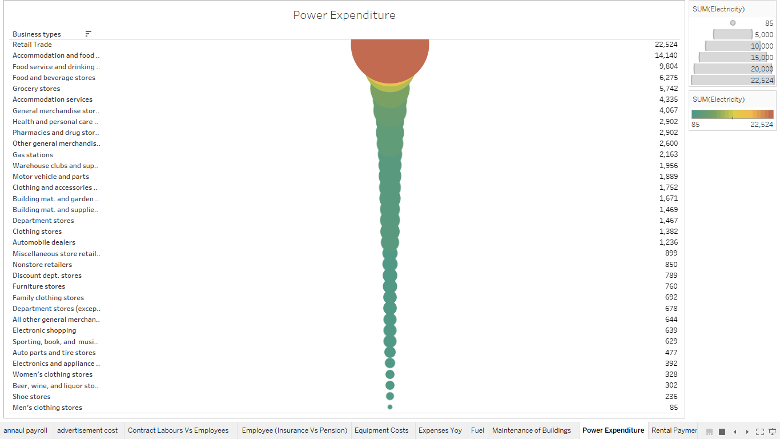

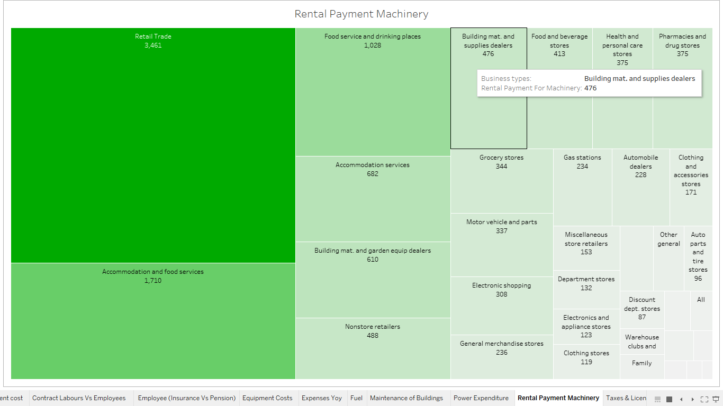

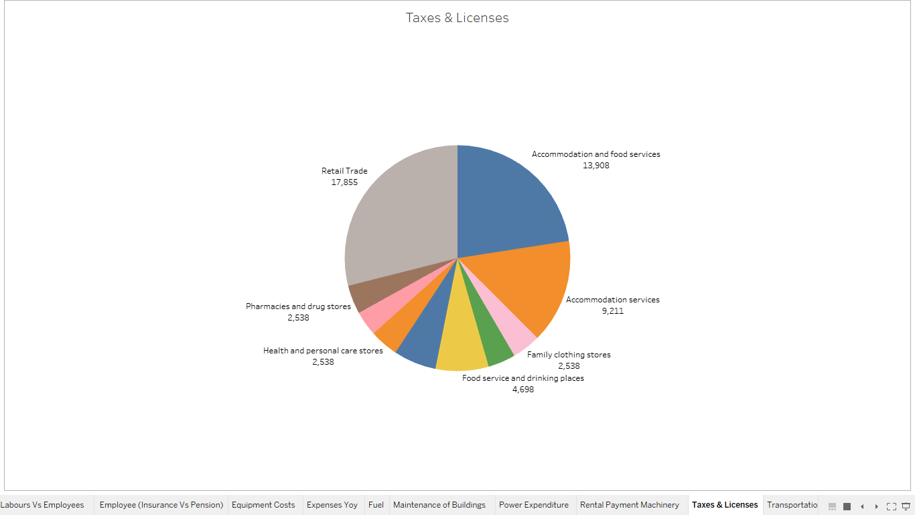

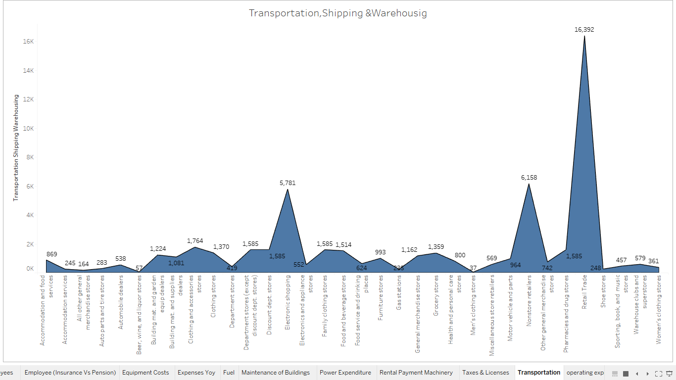

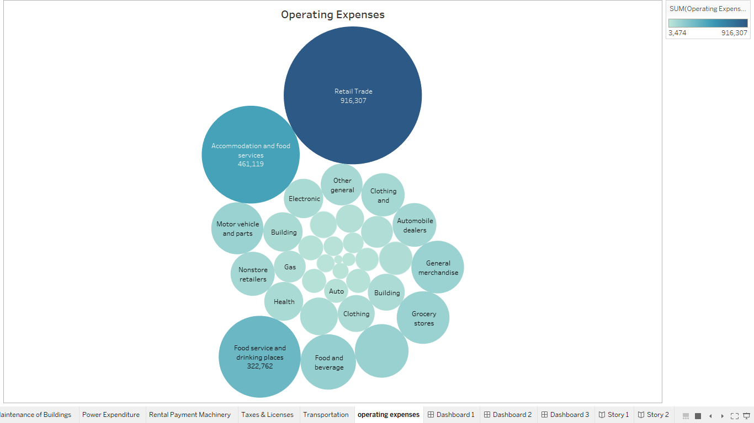

Dashboard:1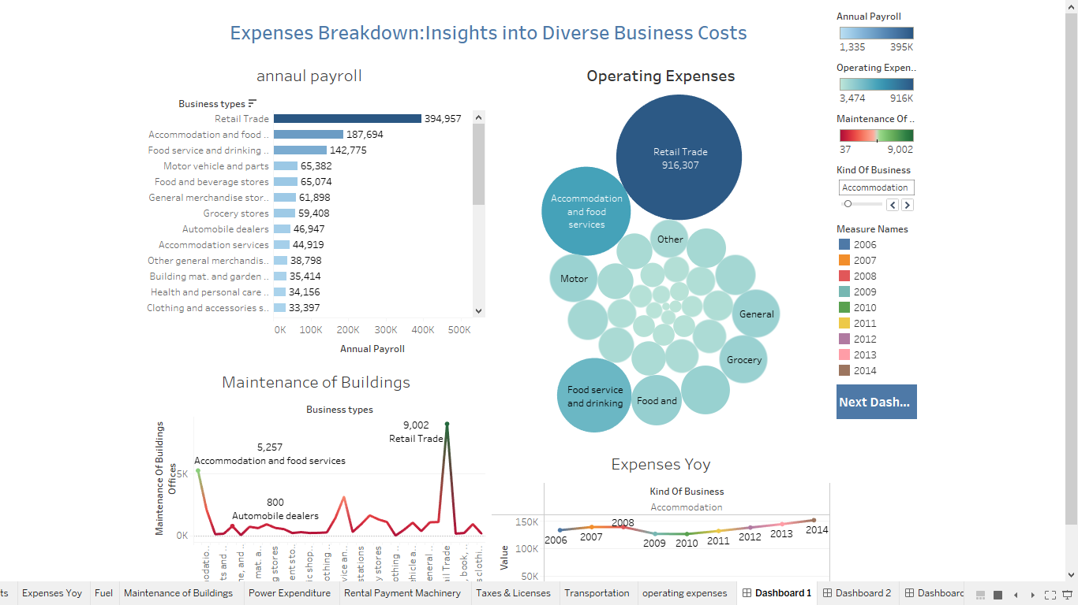
Dashboard:2
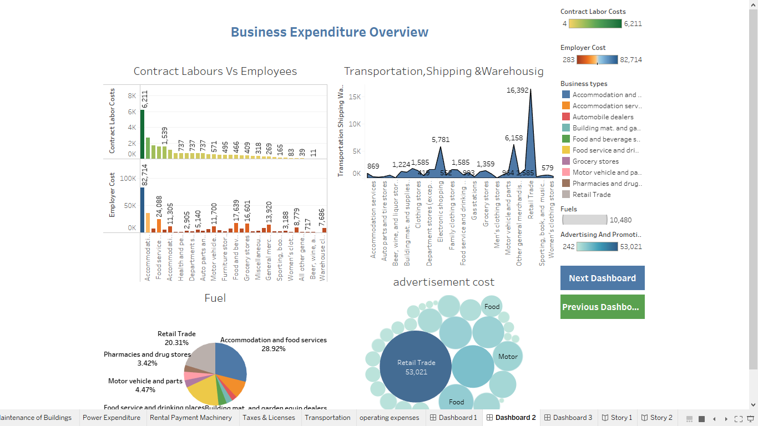

Dashboard:3
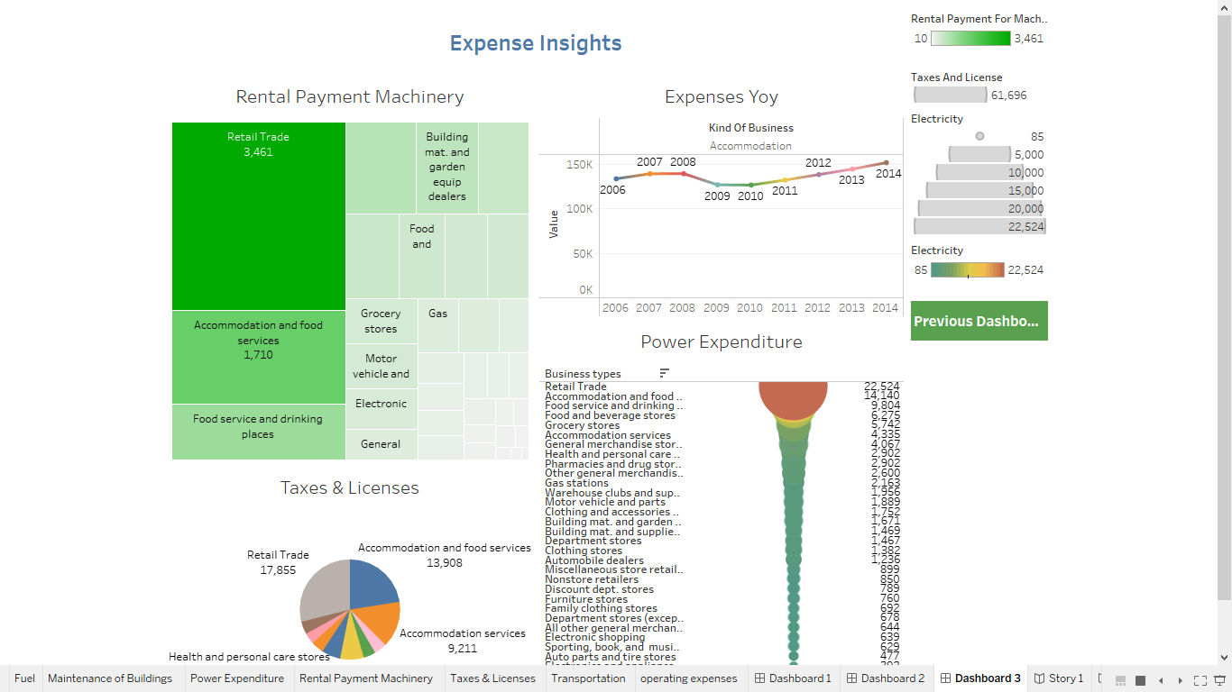

Story:1
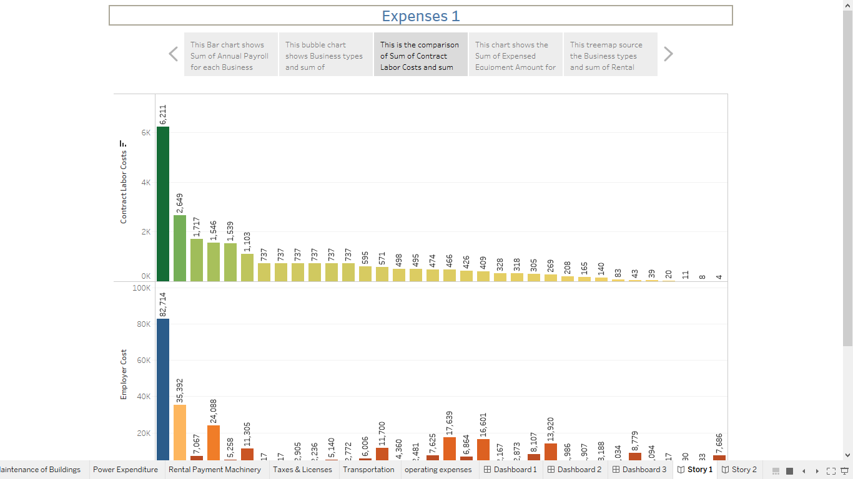
Story:2
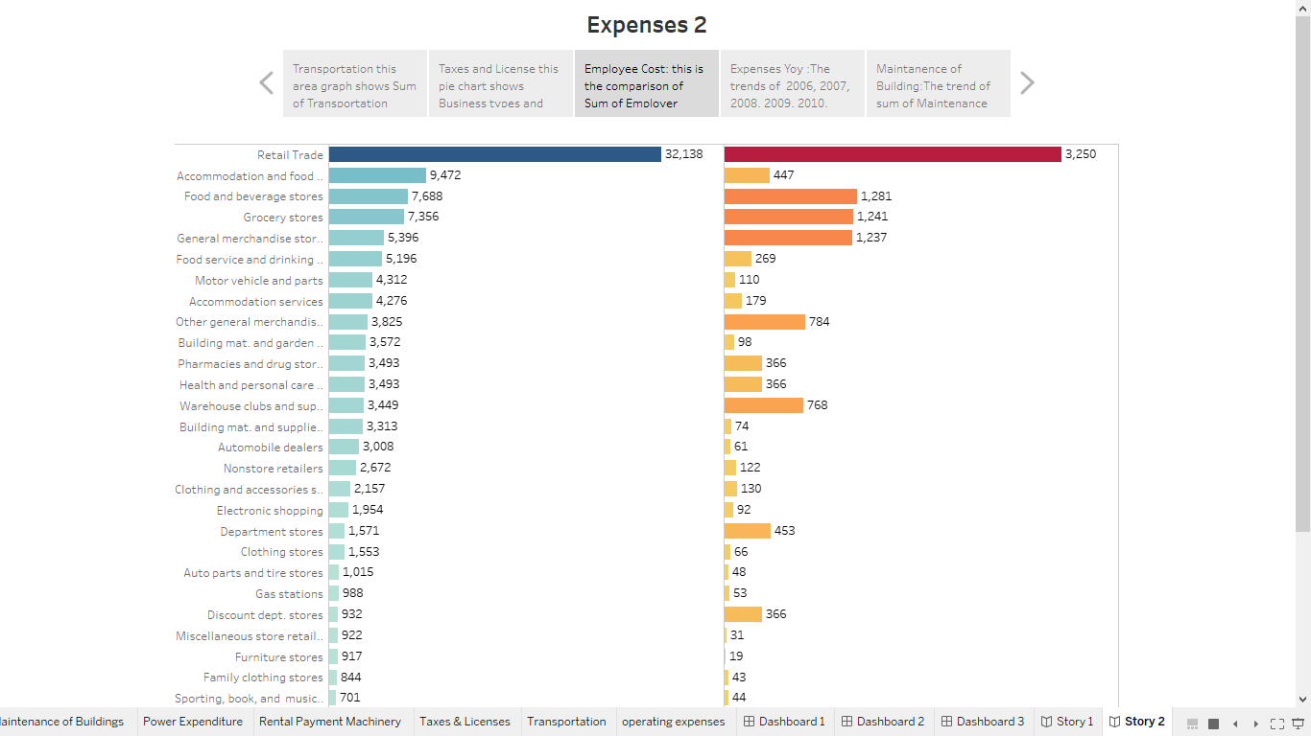
4.Advantages & Disadvantages:
1. Financial Planning: Estimating expenses helps businesses plan their budgets effectively, allocate resources, and set realistic financial goals.
2. Cost Control: It allows businesses to identify areas where costs can be reduced or optimized, leading to improved profitability.
3. Decision Making: Accurate expense estimates aid in strategic decision-making processes, enabling businesses to make informed choices regarding investments, pricing, and expansion.
4. Cash Flow Management: By predicting expenses, businesses can manage their cash flow efficiently, ensuring there are enough funds to cover operational costs.
5. Investor Confidence: Investors and stakeholders often require detailed financial projections. Estimating expenses demonstrates that the business has a clear financial plan, instilling confidence in potential investors.
Disadvatages:
1. Uncertainty: Estimating expenses involves predicting future costs, which can be challenging due to market fluctuations, unexpected events, or changes in regulations.
2. Inaccuracy: If the estimation is not based on reliable data or thorough analysis, it can lead to inaccurate financial forecasts, potentially causing financial strain on the business.
3. Time-Consuming: Creating detailed and accurate expense estimates requires time and effort, diverting resources from other essential business activities.
4. Overlooked Expenses: Sometimes, businesses may overlook certain expenses, leading to underestimation, which can result in financial difficulties when these costs arise unexpectedly.
5. Rigidity: If estimates are too rigid, businesses might miss out on opportunities for innovation or adaptation, hindering their ability to respond effectively to changing market conditions.
5.Application
1. Expensify: Expensify allows users to scan receipts, track time or mileage, and create expense reports easily. It offers features like real-time expense tracking and approval workflows.
2. Zoho Expense: Zoho Expense helps businesses automate expense reporting. It allows employees to submit expenses, and managers can approve or reject them online. It in-tegrates well with other Zoho products.
3. QuickBooks: QuickBooks offers a range of accounting services, including expense tracking. It's suitable for small to medium-sized businesses and provides comprehensive financial management tools.
4. 4.FreshBooks: FreshBooks is user-friendly accounting software designed for small businesses. It includes expense tracking features, allowing users to categorize expenses and attach receipts for record-keeping.

6.Conclusion
In conclusion, estimating business expenses is a critical aspect of financial planning and decision-making. By accurately forecasting expenses, businesses can make informed budgetary decisions, allocate resources efficiently, and ensure long-term sustainability. It is essential to consider various factors, such as operational costs, overheads, employee salaries, and unexpected expenditures, to create a comprehensive expense estimate. Regularly reviewing and updating these estimates in response to market changes and business growth is crucial for maintaining financial stability and achieving the organization's goals.
7.Future Scope:
Estimating future business expenses is crucial for financial planning and sustainability. By analyzing past trends, market conditions, and business goals, you can make informed predictions. Utilizing financial forecasting methods, such as trend analysis, regression modeling, or using specialized software, can enhance accuracy. Additionally, staying updated on industry trends and economic factors can help refine your estimates. Remember, while estimation provides a guideline, it's essential to adapt strategies based on real-time data for the most effective financial management.

